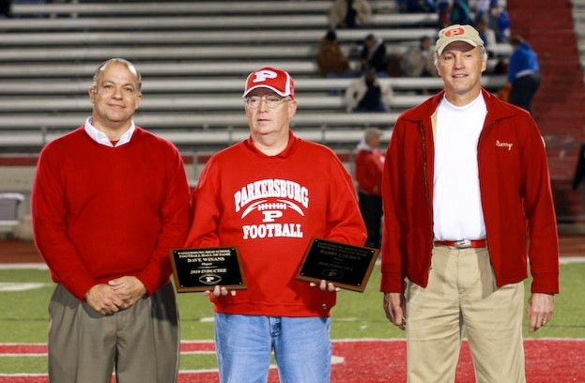
Dave Winans, Hall of Fame Chairman Carroll Jett, Dr. Barry Louden
Final 2010 Hall of Fame Inductees Are Former Hunt Winners
The final two inductees into the initial class of the Parkersburg High School Football Hall of Fame were two Hunt Award winning linemen for the Big Reds.
Dave Winans, two-time all-state tackle from the mid-1970’s and Barry Louden, who earned top lineman honors in 1967, were enshrined into the Hall of Fame Friday night prior to the final Big Red regular season home game against Capital.
Winans played on championship track, basketball and football teams at Washington Junior High School and was first team all-state tackle in 1973 and 1974 with the Big Reds. In 1973 PHS lost in the semifinals of the state playoffs and the following year were beaten in the championship game.
Not only was he captain and Most Valuable Player of the Big Reds in 1974, Winans was also third team High School All-American and won the Hunt Award as the outstanding lineman in West Virginia.
He received a scholarship and attended West Virginia University in 1975 before transferring and playing football for Fairmont State from 1976 through 1980. He was inducted into the Mid-Ohio Valley Sports Hall of Fame in 2009.
Barry Louden began playing football for VanDevender Junior High before becoming a starting member of the Big Reds as a sophomore. As a junior and senior for coach Russ Parsons he played both ways and was on all special teams.
As a senior in 1967, Louden caught 23 passes for 301 yards and three touchdowns to earn first team all-state honors on a team which won seven games and tied one. During his career he caught an estimated 45 passes for 600 yards and nine touchdowns. He capped his senior season by becoming the second Big Red to ever win the Hunt Award (Gary Virden being the first in 1962).
Louden was also a three year starter in basketball for the Big reds, leading the team in rebounding all three years. He was all-regional as a junior and made all-state honorable mention on the hardwoods as a junior and senior. He also lettered in track all three years.
He then went to Yale as a National Merit Scholarship winner and Yale National Scholar. He was the starting two-way end on the freshman team which was coached by former Green Bay Packer and Vince Lombardi teammate Harry Jacunski. He was the starting offensive end as a senior for legendary coach Carm Cozza. His Yale teams twice were Ivy League co-champion.
Following graduation from Yale in 1972 he earned his MD degree at West Virginia University School of Medicine in 1976 and completed a Neurology residency there in 1980. Since then he has practiced Neurology and Sleep Medicine with Parkersburg Neurological Associates/PM Sleep Medicine in Parkersburg and Marietta.
Dr. Louden is married to a former Big Red cheerleader, JoEllen Stark, and has four grown children who have all earned all-state honors in their various sports, Meggan, Asher, Abbie and Connor.

